1. **Write a SQL statement to find the names of teams that have played more than 3 matches.[Database: FLIS]**

Ans :

SELECT t.name

FROM teams t

JOIN matches m

ON t.team_id = m.host_team_id OR t.team_id = m.guest_team_id

GROUP BY t.name

HAVING COUNT(m.match_num) > 3;

1. **Write an SQL statement to find the first name, last name of the faculty of the department having department code as 'ME' and who have issued at least one book, such that there are no duplicate firstname-lastname pairs.[Database: LIS]**

SELECT DISTINCT f.faculty_fname, f.faculty_lname

FROM faculty f

JOIN members m ON f.id = m.id

JOIN book_issue bi ON m.member_no = bi.member_no

WHERE f.department_code = 'ME';

1. **Write an SQL statement to find the number of book-titles issued on 11th August 2021.[Database: LIS]**

SELECT COUNT(DISTINCT book_catalogue.title) AS number_of_titles_issued

FROM book_issue

JOIN book_copies ON book_issue.accession_no = book_copies.accession_no

JOIN book_catalogue ON book_copies.ISBN_no = book_catalogue.ISBN_no

WHERE book_issue.doi = '2021-08-11';

1. **Write a SQL statement to find the names of faculty (faculty_fname, faculty_lname) who did not issue any book.[Database: LIS]**

SELECT faculty.faculty_fname, faculty.faculty_lname

FROM faculty

LEFT JOIN members ON faculty.id = members.id

LEFT JOIN book_issue ON members.member_no = book_issue.member_no

WHERE book_issue.member_no IS NULL

**( please cross check its retrieving correctly,see if any student names are coming in the list)**

1. **Write a SQL statement to find the unique book titles which are issued to 'PG' students but not to 'UG' students .[Database: LIS]**

**Method 1 : ( using subquery)**

SELECT DISTINCT book_catalogue.title

FROM book_issue

JOIN members ON book_issue.member_no = members.member_no

JOIN book_copies ON book_issue.accession_no = book_copies.accession_no

JOIN book_catalogue ON book_copies.isbn_no = book_catalogue.isbn_no

WHERE members.member_type = 'PG'

AND book_catalogue.title NOT IN (

SELECT DISTINCT book_catalogue.title

FROM book_issue

JOIN members ON book_issue.member_no = members.member_no

JOIN book_copies ON book_issue.accession_no = book_copies.accession_no

JOIN book_catalogue ON book_copies.isbn_no = book_catalogue.isbn_no

WHERE members.member_type = 'UG'

);

**Method 2: (using EXCEPT)**

SELECT DISTINCT book_catalogue.title

FROM book_issue

JOIN members ON book_issue.member_no = members.member_no

JOIN book_copies ON book_issue.accession_no = book_copies.accession_no

JOIN book_catalogue ON book_copies.isbn_no = book_catalogue.isbn_no

WHERE members.member_type = 'PG'

EXCEPT

SELECT DISTINCT book_catalogue.title

FROM book_issue

JOIN members ON book_issue.member_no = members.member_no

JOIN book_copies ON book_issue.accession_no = book_copies.accession_no

JOIN book_catalogue ON book_copies.isbn_no = book_catalogue.isbn_no

WHERE members.member_type = 'UG';

1. **Write a SQL statement to find the name of the manager of the team: 'All Stars'.[Database: FLIS]**

Ans : select name from managers,teams where managers.team_id=(select team_id from teams where name='All Stars')

1. **Write an SQL statement to find the names of all teams.[Database: FLIS]**

Ans : select name from teams

1. **Write an SQL statement to find the titles of books authored by an author having first name as 'Joh Paul' and last name as 'Mueller'.[Database: LIS**

**]**

Ans : select title from book_catalogue where ISBN_no in(select ISBN_no from book_authors where author_fname='Joh Paul' and author_lname='Mueller')

1. **Write a SQL statement to find the titles of books published by 'McGraw Hill Education'.[Database: LIS]**

Ans : select title from book_catalogue where publisher='McGraw Hill Education'

1. **Write a SQL statement to display the first name and the last name of students (student_fname, student_lname) pursuing 'PG' courses.[Database: LIS]**

Ans :

select student_fname,student_lname

from students

WHERE roll_no in

(select roll_no from

members

WHERE member_type = 'PG');

### Write an SQL statement to find the city and playground of the teams whose away-jersey color(jersey_away_color) is 'Pink'. ( 1 mark )

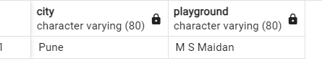

SELECT city, playground

FROM teams

WHERE jersey_away_color = 'Pink';

### Write a SQL statement to find the names of teams that have played more than 3 matches ( 1 mark )

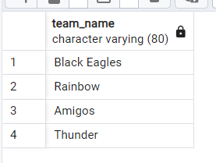

SELECT t.name

FROM teams t

JOIN matches m

ON t.team_id = m.host_team_id OR t.team_id = m.guest_team_id

GROUP BY t.name

HAVING COUNT(m.match_num) > 3;

### Write an SQL query to retrieve a unique list of player names in uppercase, who were born on or after '2000-01-01'. Sort the results alphabetically in descending order and only display the first 5 names. ( 2 mark)

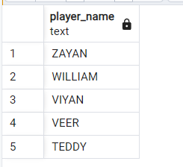

SELECT DISTINCT UPPER(name) AS player_name

FROM players

WHERE dob >= '2000-01-01'

ORDER BY player_name DESC

LIMIT 5;

### Find the average score of host teams for each city. Only include cities where the average host team score is at least 2 and there are more than 3 matches. ( 2 marks )

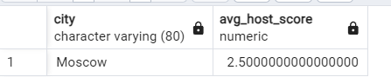

SELECT t.city, AVG(m.host_team_score) AS avg_score, COUNT(*) AS match_count

FROM matches m

JOIN teams t ON m.host_team_id = t.team_id

GROUP BY t.city

HAVING AVG(m.host_team_score) >= 2 AND COUNT(*) > 3;